**Project Design Phase-I**

**Solution Architecture**

|  |  |
| --- | --- |
| Date | 2 November 2022 |
| Team ID | PNT2022TMID31045 |
| Project Name | Real time River Water Quality Monitoring And Control System |
| Maximum Marks | 4 Marks |

**Solution Architecture:**

Our Aim is to develop a system for continous monitoring of river water quality at remote places using WSN with low cost and more accuracy.

1. To measure the parameters such as PH,Turbidity,Total dissolved solid and temperature using sensor.
2. Assemble the data from all the sensor and send it to base station using ESP32.
3. Integrate all the data from software then give it to MPC Buoy(mobile app)and measure the quality of water.
4. Send SMS to an authorized person when water quality detected not match the preset standards.
5. The Data aggregator can retrieve the analysis result and transfer to app running on laptops,mobile phones in IOT cloud.

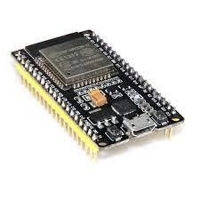 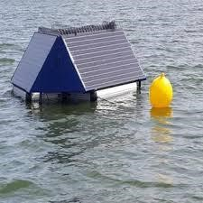

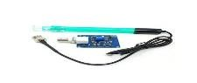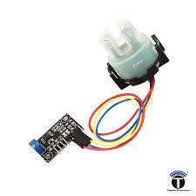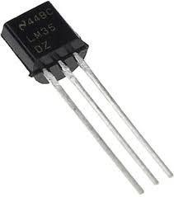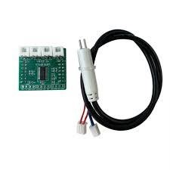

**Sensors ESP32 MPC Buoy**

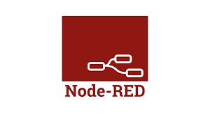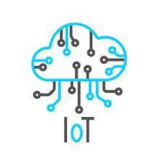

**Authority Web UI Node RED IOT**

**Platform**

**CLOUD**

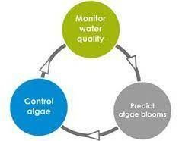

**Monitor & control algae**

**Alert** 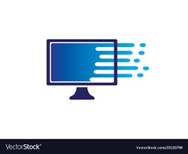

**Display**